ChE 321 – Chemical Reaction Engineering – Fall 2019
Student Learning Outcome 1
Rubric for assessment problem on the midterm computational exam (Problem #1)
Application of mass balances to a plug-flow reactor with recycle to improve conversion.

SLO 1  Performance Indicator (PI) | (1) Unsatisfactory | (2) Developing | (3) Satisfactory
2. Solve engineering problems by using the concepts of algebra, calculus, differential equations and/or linear algebra  Problem MATLAB Implementation  20 pts | applies concepts of algebra, calculus, differential equations and/or linear algebra to solve chemical engineering problems  (<10 pts) | Shows nearly complete understanding of applications of calculus and/or linear algebra in problem-solving  (10 - 15 pts) | Does not understand the application of algebra, calculus, differential equations and/or linear algebra in solving chemical engineering problems  (> 15 pts)
4. Translates academic theory into engineering applications  Problem Analysis  10 pts | Translates academic theory into engineering applications and accepts limitations of mathematical models of physical reality  (< 3 pts) | Some gaps in understanding the application of theory to the problem and expects theory to predict reality  (3-6 pts) | Does not appear to grasp the connection between theory and the problem  (>6 pts)
6. The uses of appropriate resources needed to solve problems  Problem Using ODE Solvers  20 pts | Uses no resources to solve problems  (<10 pts) | Uses limited resources to solve problems  (10 - 15 pts) | Uses appropriate resources to locate information needed to solve problems  (> 15 pts)

Averages:

Performance Indicators: (2) 2.61 (4) 1.83 (6) 2.22 Overall Average: 2.22

The average scores for PI 2 and PI 6 are similar, but the scores for PI 4 is slightly lower. This is because the analysis part of the assessment (PI 4) required the successful convergence of the solution (PI 6). Some of the students did get full convergence resulting in varying concentration and conversion profiles. Clearly, most students were strong in formulating the engineering system and model equations in MATLAB, and a majority 12/18 were satisfactory or higher in applying the engineering principles to solve the three problems.
To improve the PI 4, the instructor has developed examples of fully converged simulations in MATLAB and provided tutorials on selecting solvers and convergence criteria to get numerically correct solutions. For each concept taught in the class, there was a follow-up live-session to code and simulate reaction engineering problems. The live-examples were very helpful not only in visualizing the theoretical concepts taught in the class but also in problem solving for home assignments and exams.

CHE 321 – Computer Exam
(Open Notes, Open Books)
Time: 8:00 – 9:45 am

Name: _____________________

Question: Consider a plug-flow reactor with recycle as shown in Figure below.
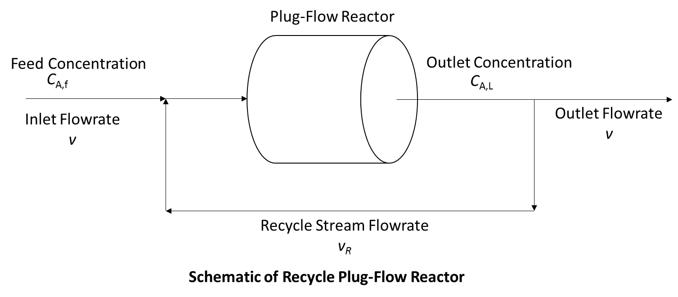
A liquid phase reaction 2A B C is conducted in a plug-flow reactor. The rate expressions are given as and . The feed contains only reactant A of concentration C_{A,f} and it is mixed with a recycle stream containing unconverted reactant of concentration C_{A,L} before entering the plug-flow reactor. The flowrates of feed stream is v and the flowrate of recycle stream is given as v_{R}. The plug-flow reactor has length L, cross-sectional area A, and volume V.
The physical parameters are given below
= 0.001 L mol⁻¹ s⁻¹
= 0.0001 s⁻¹
C_{A,f} = 40 mol L⁻¹
L = 10 m
A = 0.01 m²
v = 1 L s⁻¹
- (50 points) The steady-state continuity equation for A, B, and C in the recycle plug-flow reactor can be written as
The boundary conditions are given as
Solve above ODEs to obtain concentrations of A, B, and C as function of volume V of reactor when .
[Hint: Assume , and in the boundary conditions and solve the above ODEs. Update values of in the boundary conditions using the solution of ODEs and solve the ODEs again. Iterate until the values of are converged.]

Solution:

%%----Main File Start---------

clc;
clear all;

L=10;
A=0.01;
caf=40;

v=1;
vr=1;
k1=0.001;
k2=0.0001;

%Outlet boundary conditions
cal=caf;
cbl=0;
ccl=0;

cend(:,:)=zeros;

for i=1:1:10

cend(i,1)=cal;
cend(i,2)=cbl;
cend(i,3)=ccl;
cend(i,4)=i;

%Inlet boundary conditions
cao= (v*caf + vr*cal)/(v+vr);
cbo= (vr*cbl)/(v+vr);
cco= (vr*ccl)/(v+vr);

volspan=[0 A*L*1000]; %total volume range

%Initial condition for the solver
cinit=[cao; cbo; cco];

[vol,c] = ode45(@che321_func,volspan,cinit);

%Change cal,cbl,ccl in every iteration
%Size of vol matrix
s=size(vol);
cal=c(s(1,1),1);
cbl=c(s(1,1),2);
ccl=c(s(1,1),3);

end

graph=plot(cend(:,4),cend(:,1),cend(:,4),cend(:,2),cend(:,4),cend(:,3));
set(graph,'LineWidth',5)
xlabel('iteration');
ylabel('Concentration');
legend('A','B','C','Location','Best')
set(gca,'FontSize',20)

subplot(2,1,1)
graph2=plot(vol,c(:,1),vol,c(:,2),vol,c(:,3));
set(graph2,'LineWidth',5)
xlabel('Volume');
ylabel('Concentration');
legend('A','B','C','Location','Best')
set(gca,'FontSize',20)

subplot(2,1,2)
graph2=plot(vol,(caf-c(:,1))/caf);
set(graph2,'LineWidth',5)
xlabel('Volume');
ylabel('X');
legend('Conversion','Location','Best')
set(gca,'FontSize',20)
%% ------Main File End ----------

%% ------Function File Start ----------
function dcdvol = che321_func(vol,c)

v=1;
vr=1;
k1=0.001;
k2=0.0001;

dcdvol=[-k1*c(1)*c(1)/(v+vr); (k1*c(1)*c(1)-k2*c(2))/(v+vr); k2*c(2)/(v+vr)];
%% ------Function File End ----------

%% Concentration and conversion profiles in the reactor

Performance Indicators-Specific Grading
PI 2 – Understanding the physical problem – Governing equation and boundary conditions and correctly implementing them on MATLAB to solve for concentration profiles. (20 points)
Unsatisfactory <10 points, Developing <15 points, Satisfactory <20 points
PI 6 – Identify appropriate subroutines to solve differential equations and implement criteria to realize convergence. (20 points)
Unsatisfactory <10 points, Developing <15 points, Satisfactory <20 points
PI 4 – Analyze the trends in concentration profiles of reactant, intermediate, and product; relate those to conversion profile and realize the impact of recycle on conversion. (10 points)
Unsatisfactory <3 points, Developing <6 points, Satisfactory <10 points

